WATER BOT

ABSTRACT:
Among some of the major environmental disasters affecting our planet today, the degradation of water bodies is one of the greatest, yet most overlooked problems. The pollution of water bodies causes change in water cycle, increase in amounts of natural disasters such as floods/droughts and affects aquatic ecosystems to a great extent. The first step to moving towards a better future is to repair the damage that has already been done and that is what this project aims to achieve. The main objective of this project is to build an automated machine that cleans up what mankind has done over decades of exploitation. The project, titled ‘The Waterbot’ is essentially a robot that addresses the primary pollutants affecting the local bodies such as lakes and canals and picks up the floating debris, Shards of plastics and cleans up any alien aquatic matter (Algae) present on its surface. Thereby allowing penetration of sunlight, restoring aquatic life. However, the floating trash is not the only thing polluting a clean lake, there are various types of chemicals that change the pH and TDS levels of the water body, the waterbot comes in handy in these situations as well. After the water body is free of trash, the Waterbot analyses the water for pH, dissolved oxygen, turbidity, salinity, TDS, and treats the water accordingly with the help of AI by releasing chemicals and restores the aquatic life. Therefore, the presented project is a potentially efficient vehicle that aids in the overall restoration of polluted water bodies.

FIELD ON THE INNOVATION:
The idea aims to introduce a robot that collects the floating trash on water bodies. The main functions of the waterpot are, detecting and collecting waste materials from the surface of the water body and to test the water body for chemical impurities. The robot, also known as the water bot uses a 360-degree camera to detect and locate trash and further uses artificial intelligence, depth sensors and lidar sensors to improve precision and to identify the type of waste present on the surface.
The body of the water bot is made of Styrofoam which makes it a good, lightweight material that can float and carry heavy loads of trash. It uses 100% clean energy to power its thrusters therefore not causing any potential harm to aquatic life. For movement The water bot’s motors can give a thrust up to 10,000 rpm by only consuming little power (i.e. it can hold a 5000maH battery from 100 to 25 for 3+ Hours.). The waterbot can also work as a ‘floating laboratory’. It measures the temperature, pH and dissolved solids present in the water body and treats the water accordingly with the help of AI to determine amounts of chemicals to be added . The process of treating the water includes, introducing alum as a flocculant for handling water turbidity, adding required amounts of acidic/basic compounds to neutralise the pH, etc.
The specialty of the Waterbot apart from its two in one feature, is that it is scalable and can be used on any scale depending on the size of the waterbody and the manufacturing cost will barely vary. from miniature bodies such as local ponds and lakes to canals and river banks the waterbot has countless applications. The waterbot is shaped like a box with flaps that move inward to push the trash inside. A net like structure is placed at the back of the bot with enough spacing to let the excess water outside. There are two thrusters that are placed at the back, this enables fast forward movement and equally efficient turning of the bot towards the detected location. The waterbot is automated and can be operated with minimal human intervention, however it consists of a manual mode as a back up and can be operated very easily through a mobile application. The waterbot can also be deployed in areas that cannot be accessed by humans and transmits the data collected on the isolated body.
There have been numerous efforts to build trash collecting robots, however none of them have been too successful in making it to the markets due to various reasons such as storage capacity, size, efficiency and cost. The waterbot solves all of these problems with its customisable structure and cost effective nature. It also provides a deep cleaning of the water body with the help of chemicals that hasn’t been achieved in years of trial. Therefore its unique structure, material composition and function makes it a one of a kind innovation.

CONTROL FLOW:
- The raspberry pi is powered by a 5000mah power bank and connects to the device via specific mobile hotspot
- The thrusters are connected to their respective ESC.
- A 9g servo motor is placed to for control of ramp
- Both the thrusters and the 9g servo ramp are powered by 5000 mah batteries
- The sensors [Temperature and D.S.W] are placed at a respective positions for measurements.
- All the components placed are connected to the arduino board for process
- The Arduino is in turn connected to the lora comm module.
- The lora comm from the bot is then connected to then connected to the module present in the laptop, ultimately establishes a pitch perfect connection and makes it possible to command the bot remotely.

Images and circuit diagram:
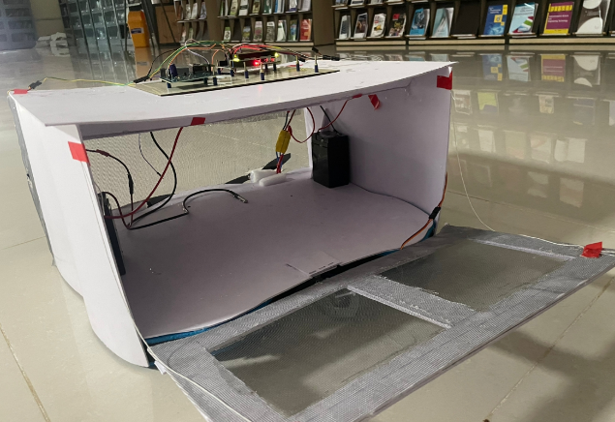

CONCLUSION:
To conclude, the waterbot is an effective, automated system that aids in the overall restoration of damaged and polluted water bodies. Thereby, creating a healthy and safe environment for future generations.

